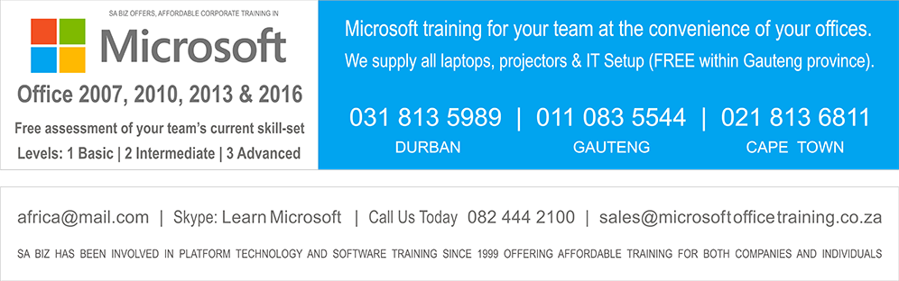
Microsoft Office Training | On-Site Training Solutions | Contact Microsoft Training | Introductory Special Offers

Access | Excel | Project | Office | Outlook | PowerPoint | Windows | Word | PC Course

• Free skills assessment of your team
• Free laptops, projectors & IT setup
• Microsoft 2007, 2010, 2013 & 2016
call us now or fill in below

fill details below and we will call you immediately
Thank you

Microsoft Word Training Course
Microsoft Word is used by businesses, small and large. Whether your corporation wants to write a letter, create a pamphlet or even publish a blog online, Microsoft Word is the corporate choice.
Microsoft Excel Training Course
Microsoft Excel training allows your business to evaluate, supervise and communicate the data that permits you to make well-informed choices. Whether your team want to create financial reports, or to come to a decision which external associate offers the best value for money, Microsoft Excel is crucial to modern business operations.
Microsoft Outlook Training Course
Microsoft Outlook offers your company a total solution for time management and communication. You and your staff can competently control your communications, internal and external, organise your work better, and share information with colleagues - all from Microsoft Outlook.
Microsoft PowerPoint Training Course
Microsoft PowerPoint has turned out to be commonplace in any company, whether it is a sales presentation to clients or internal use. When used properly, it lets you and your staff produce highly professional and dynamic presentations - improving the possibility of it being a success.
Microsoft Access Training Course
Microsoft Access is an extremely powerful database software program allowing custom data search manipulation and structured intergration of information. Learn to use the full potential of Microsoft Access through our expert Microsoft facilitators.
Microsoft Office Training Course
A Microsoft Office training course will help your staff get the most out of this powerful suite. Microsoft Office is filled with tools and features intended to improve office efficiency. Microsoft Office training classes' offers organized approaches to learning that will help your team become skilled in Microsoft office products without wasting valuable time experimenting.
Microsoft Windows Training Course
One of the best ways to learn Microsoft Windows is with our on-site training. It gives your staff a chance to learn by seeing it , hearing it, and doing it. We make this training work by sending our master instructors to your location armed with a self-contained Microsoft Windows training environment.
Computer PC Training Courses
We provide a professional on-site computer PC training Courses using our modern laptop computers. Microsoft Office Training offer high quality, great value Computer PC training courses in the Microsoft Office suite of programs. Our courses are run on the customers' site, as it cuts down on your travelling expenses.
Microsoft Project Training Course
Discover how to effectively plan, implement, and control projects using Microsoft Project. The knowledge you gain from this course will help you avoid going down dead-end alleys and prevent you from overloading your schedule. No matter how complex your projects are, Microsoft Project will help you cut them down to size.

Microsoft Office Training Home | On-Site Training Solutions | Contact Microsoft Office Training | Microsoft Office Training Course | Microsoft Access Training Course | Microsoft Word Training Course | Microsoft Excel Training Course
Microsoft Outlook Training Course | Microsoft PowerPoint Training Course | Microsoft Windows Training Course | Microsoft Internet Explorer Training Course | Computer PC Training Courses

SA Biz On-Site Training Copyright 2014 (c)

COMPUTER TRAINING COURSES
www.microsoftofficetraining.co.za/
Corporate training at your offices. No Individuals - Groups from 3 – 25

